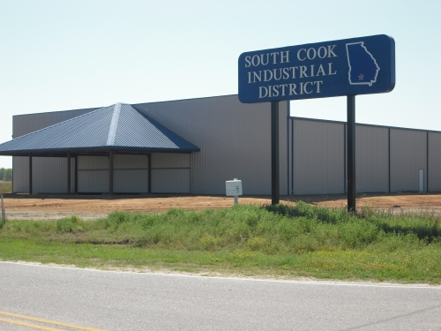
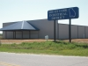
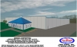
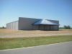
Contact:
Lisa S. Collins, CEcD, EDFP
Director of Economic Development
P O Box 800
Adel, GA 31620
tel. 229.896.2575 cell 229.308.3785
email: lisacollins@cookcountyedc.com
Adel / Cook County Spec Building
- New construction in South Cook Industrial Park on US 41 South
- Sits on 7.5 acres with an additional 10 acres for growth
- Building is expandable to 60,000 square feet
- Has an attached office of 1560 sq ft.
- Owner will build out to suit
- Prime location: building sits on corner lot in new 350 acre G.R.A.D. (Georgia Ready for Accelerated Development) Industrial Park
- Served by interchange exits 32 and 37 from Interstate I-75
- 3 miles from I-75 via exit 32 or exit 37
- In the city limits of the City of Adel with an ISO rating of 3
Property Details
- Total Square Feet: 18,000 sq. ft.
- Office Space: 1560 sq. ft.
- Year Built: 2009
- Lot Size: 7.5 acres

Additional Information
- City: Adel
- County: Cook
- Highway: U.S. 41
- Interstate: I - 75
- Rail: Norfolk Southern
- Airport: Adel-Cook County Airport (general aviation)
- Ceiling (Max.): 24 ft.
- Current Zoning: Industrial
- Water: City of Adel
- Sewer: City of Adel
- Gas: City of Adel
- Electricity: GA Power - if over 900 KV, customer choice
- Telecommunications: City of Adel, Windstream

